Christensen Animal Services is the company I will be making a database for. I started pet sitting on the side in 2024 to make money towards paying for college. While I am glad it pays well, I also enjoy giving my clients the peace of mind they need when leaving their animals with someone new. I have always had animals while growing up and currently have two cats. I have over 15+ years of experience with animals. I use Rover but since starting have grown outside of the application and have trouble keeping up with all of them. I mainly watch dogs and cats but to increase my clientele I will allow other animals to be included. These can be any other animals such as birds, fish, etc. Most of my clients prefer me to do overnights or house-sitting with their animals. I offer sitting and walking their animals but if asked will give them additional grooming. My rates depend on the number of animals and the type of animal. It also can depend on the amount of time I will be spending with them. The holidays I charge more as well due to the influx of clients needing me to be there for them. As there are many variables to my rates it can be difficult to keep up so I am hoping by creating this database it will ensure the ease of it. The database will make managing my animal sitting gigs smoother. The five tables I will be using are Clients, Animals, Bookings, Payments, and Services.
My ERD for Christensen Animal Services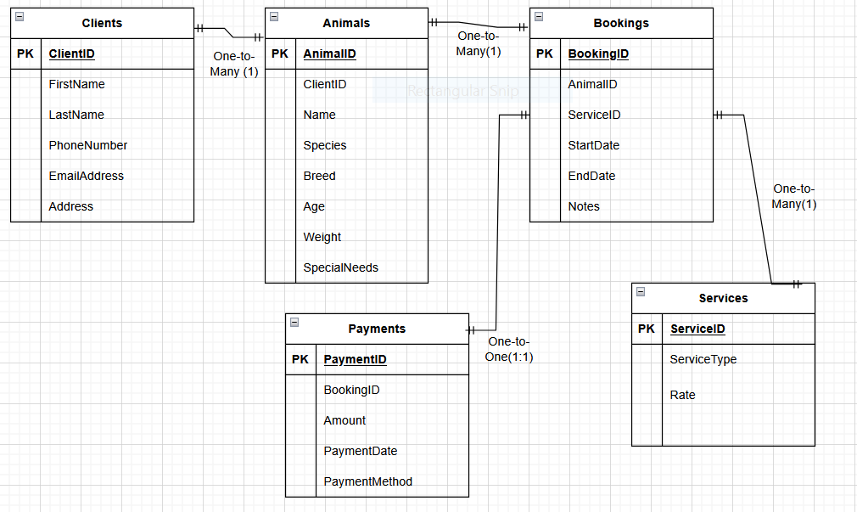
Table 1-Animals
Field name | Data Type | Field Size | Required?
AnimalID | AutoNumber | Long Integer
ClientID | Number | Long Integer
Name | Short Text | 15
Species | Short Text | 30
Breed | Short Text | 30
Age | Number | Double
Weight | Number | Decimal
Gender | Short Text | 1
Treats | Short Text | 255
Veterinary Info | Long Text
Microchipped | Yes/No
Spayed/Neutered | Yes/No
Friendly with dogs | Yes/No
Friendly with cats | Yes/No
Friendly with children | Yes/No
Comments | Long text
Table 2-Bookings
Field name | Data Type | Field Size | Required?
BookingID | AutoNumber | Long Integer
AnimalID | Number | Long Integer
ServiceID | Number | Long Integer
StartDate | Date/Time | 30
EndDate | Date/Time | 30
Notes | Long Text

Table 3- Clients
Field name | Data Type | Field Size | Required?
ClientID | AutoNumber | Long Integer
FirstName | Short Text | 30
LastName | Short Text | 30
PhoneNumber | Short Text | 11
EmailAddress | Short Text | 30
Address | Short Text | 255

Table 4-Payments
Field name | Data Type | Field Size | Required?
PaymentID | AutoNumber | Long Integer
BookingID | Number | Long Integer
Amount | Currency
PaymentDate | Date/Time | 30
PaymentMethod | Short Text | 20
Table 5-Services
ServiceID | AutoNumber
ServiceType | Short Text | 30
Rate | Currency
Additional Dog | Currency
Additional Cat | Currency
Extended Stay | Currency
Holiday Rate | Currency

Table Descriptions, Primary Keys, Parent Tables:
Table Name | Description | Primary Key(s) | Parent Table (s_
Clients | Stores client information such as name, contact details, and address. | ClientID | None
Animals | Stores information about animals, species, breeds, vet info. | AnimalID | Clients
Services | Stores details about services offered, rates for services, and types of services. | ServiceID | None
Bookings | Contains details about bookings made by clients for services for their animals. | BookingID | Animals,Services
Payments | Records payment information for bookings, payment method, and amount. | PaymentID | Bookings

Creating Christensen Animal Services in MySQL Screenshots:
Creating Database:
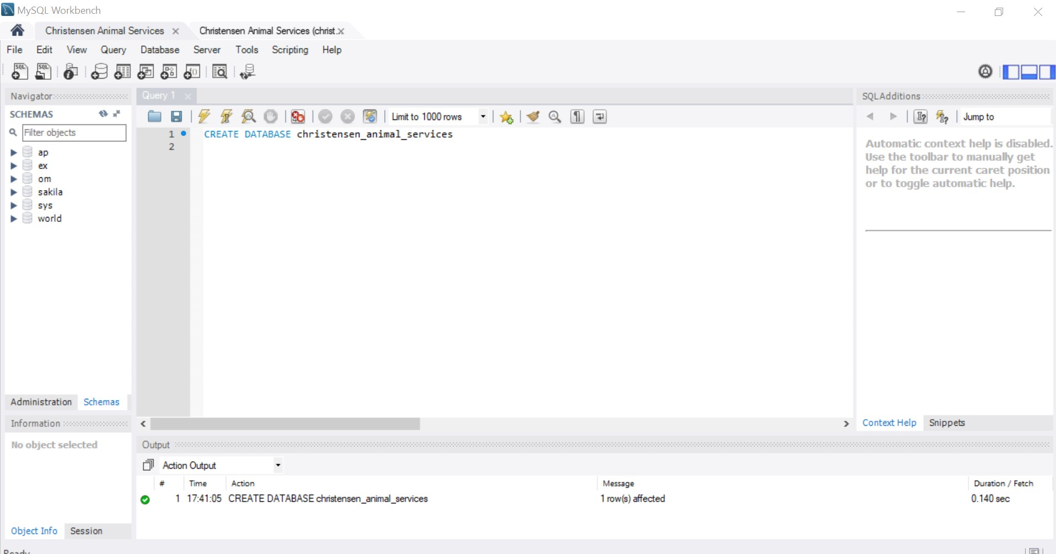
Creating Tables:
Animals:
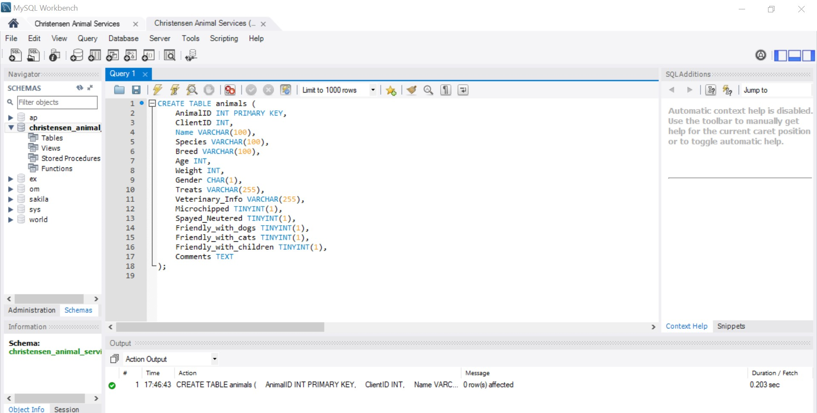
Clients:
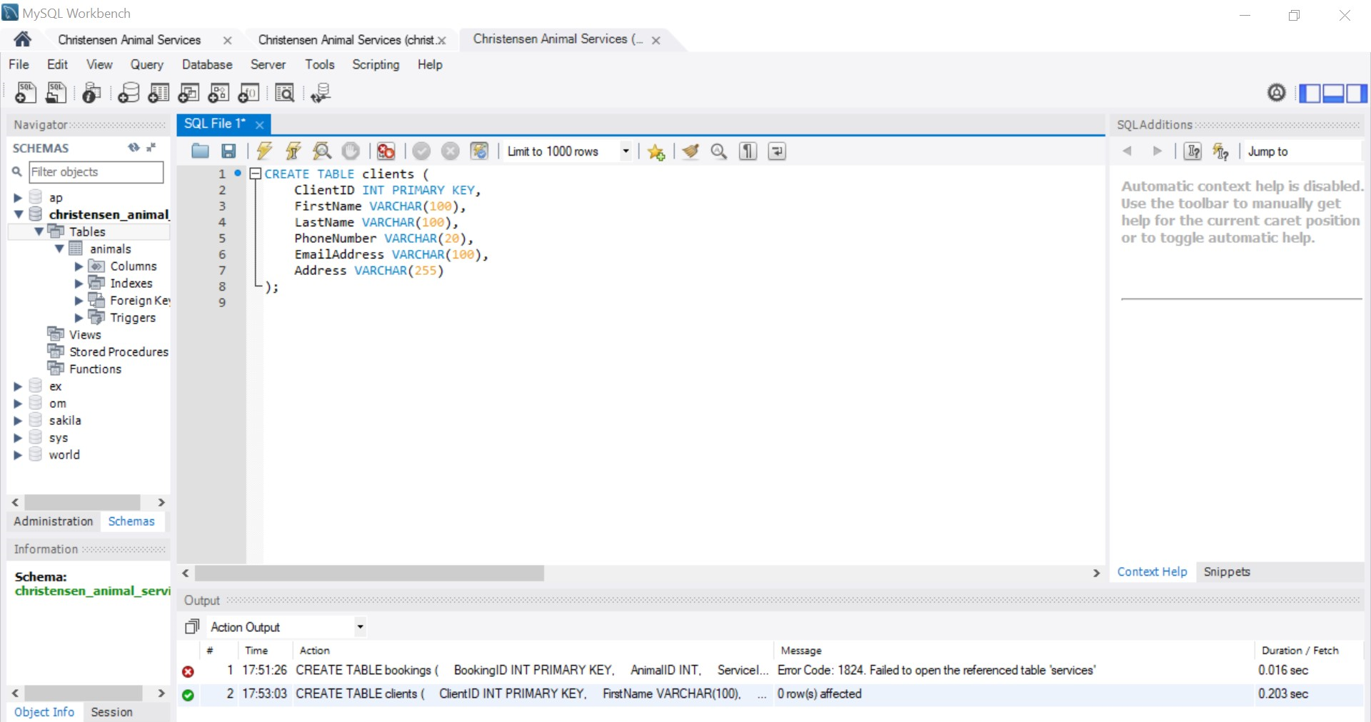
Services: 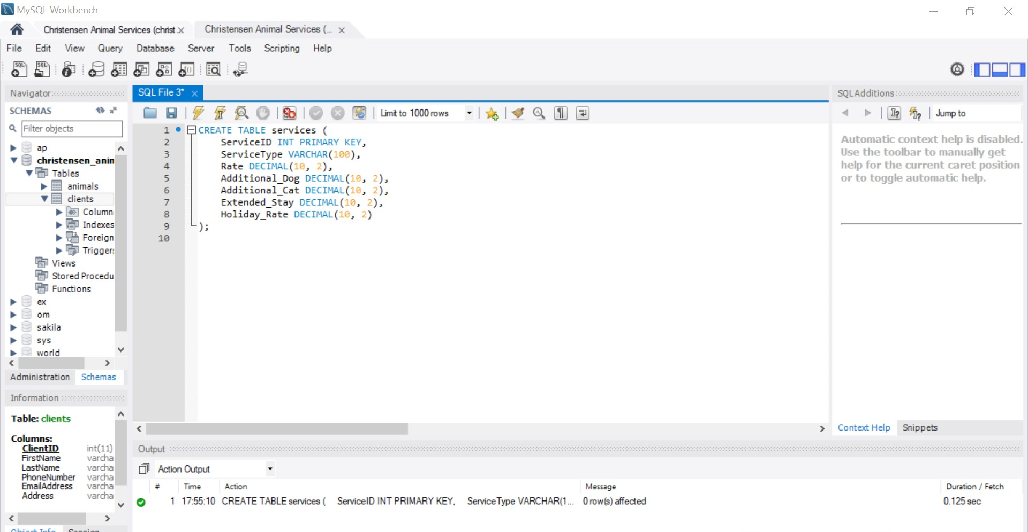
Bookings: 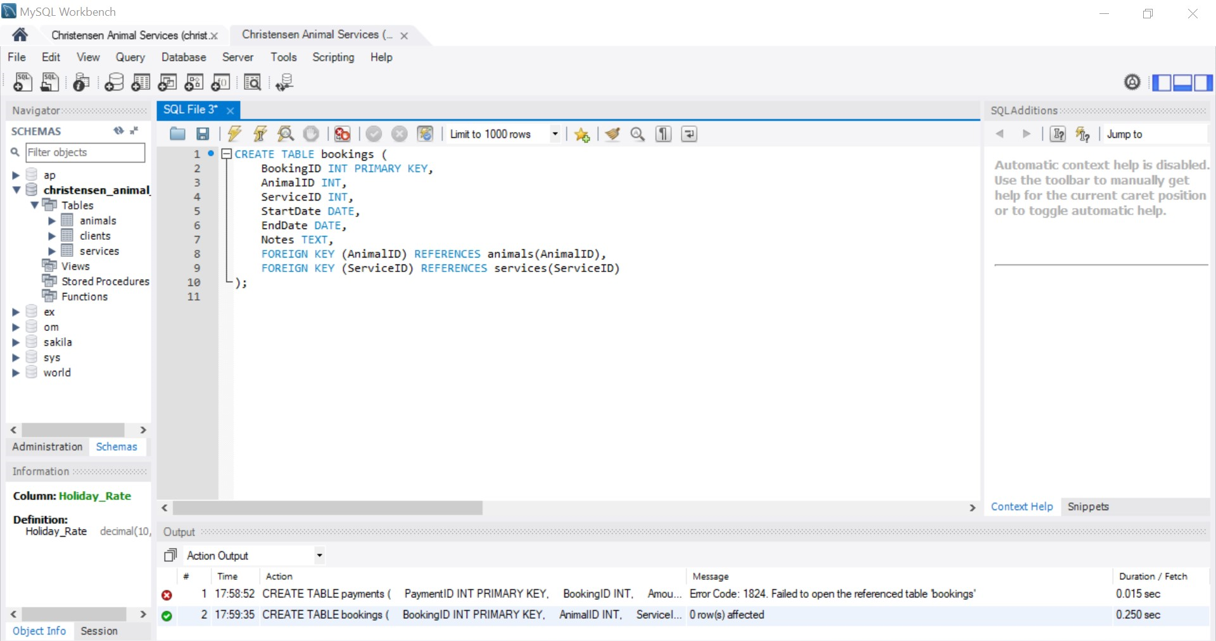
Payments: 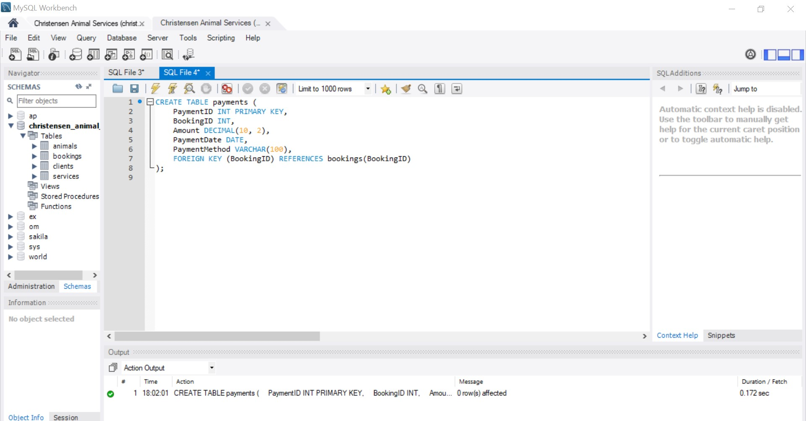
Inserting Data:
Animals:
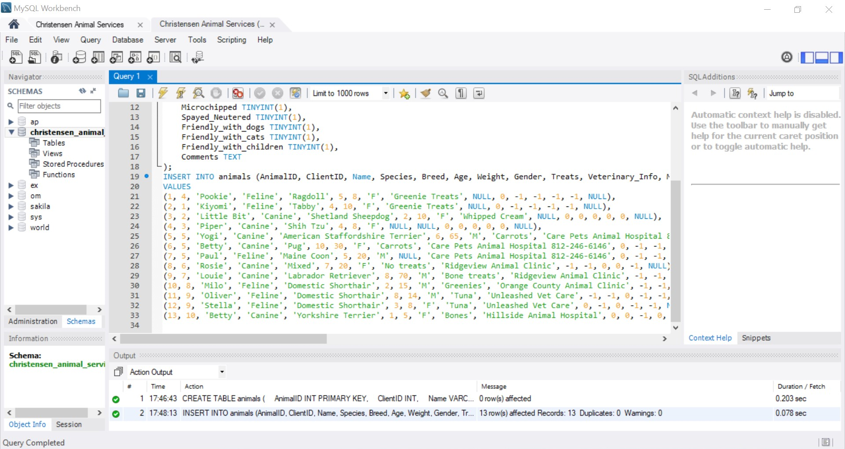
Clients:
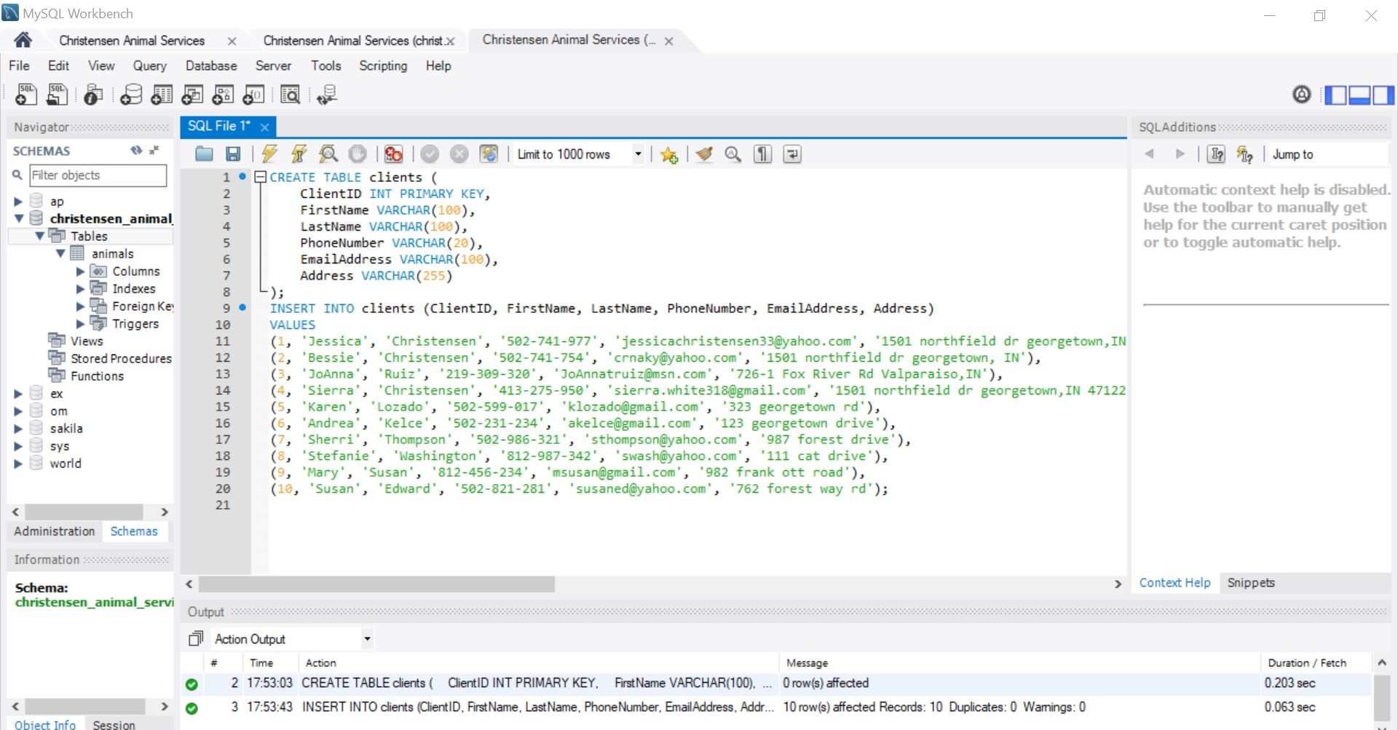
Services: 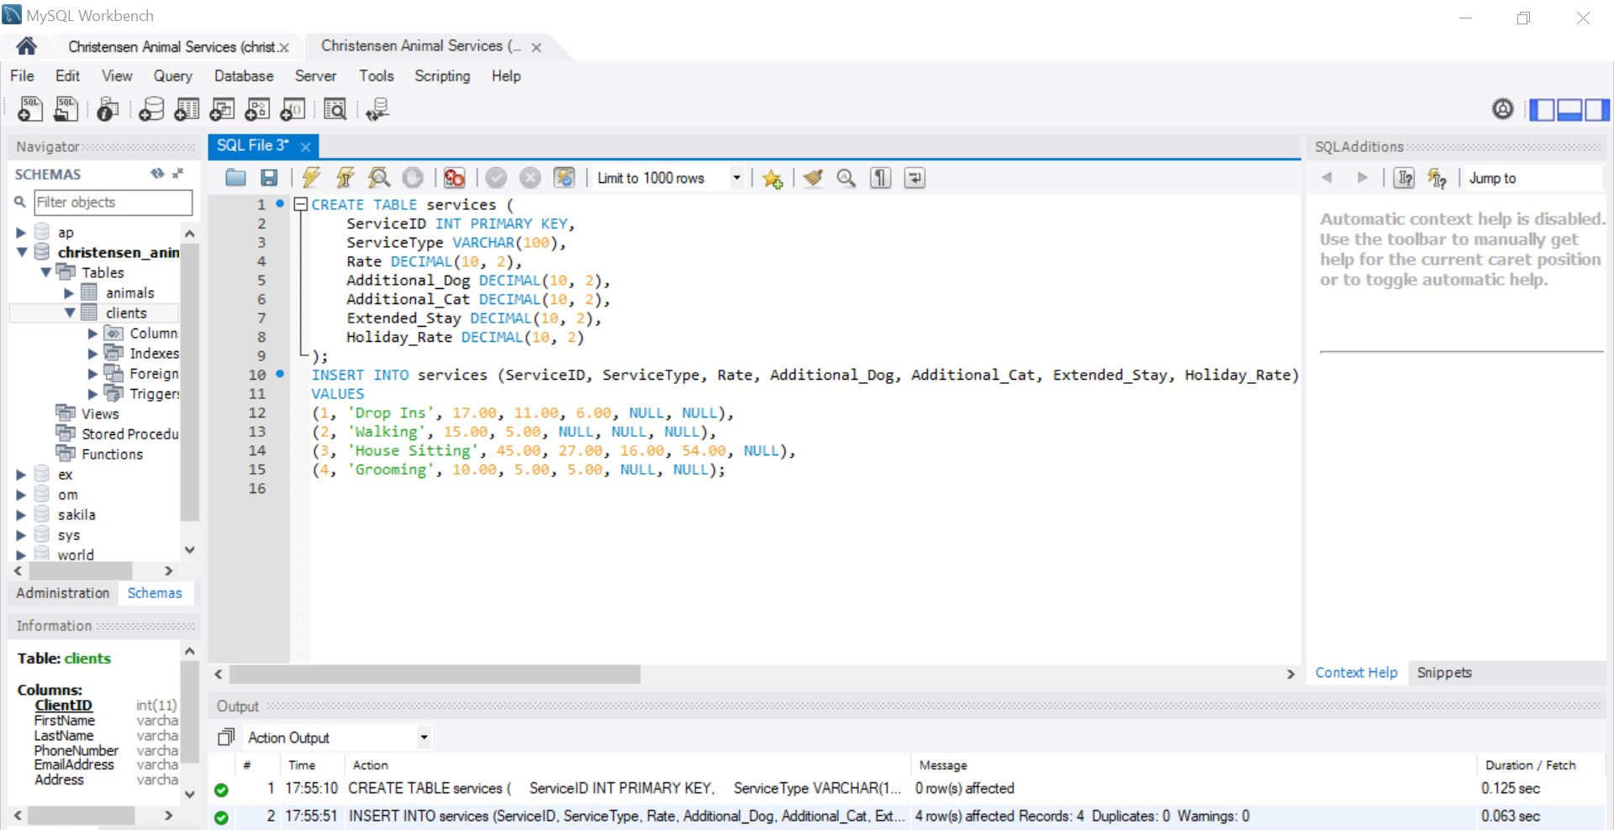
Bookings: 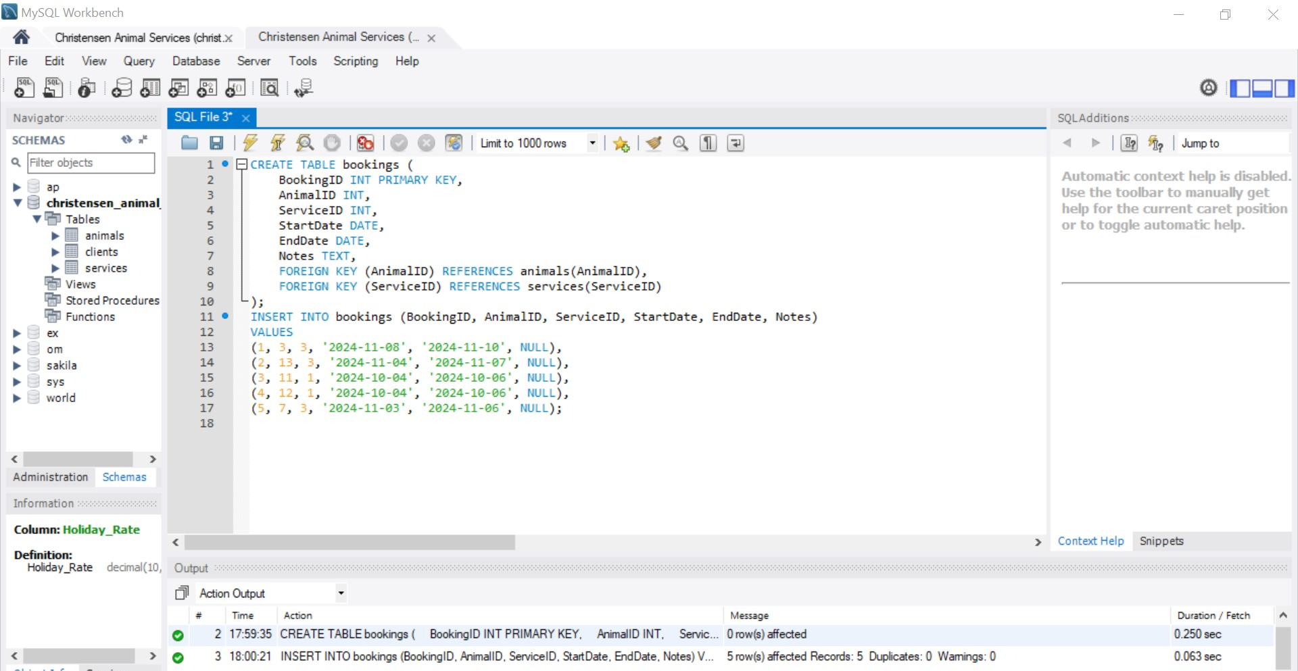
Payments: 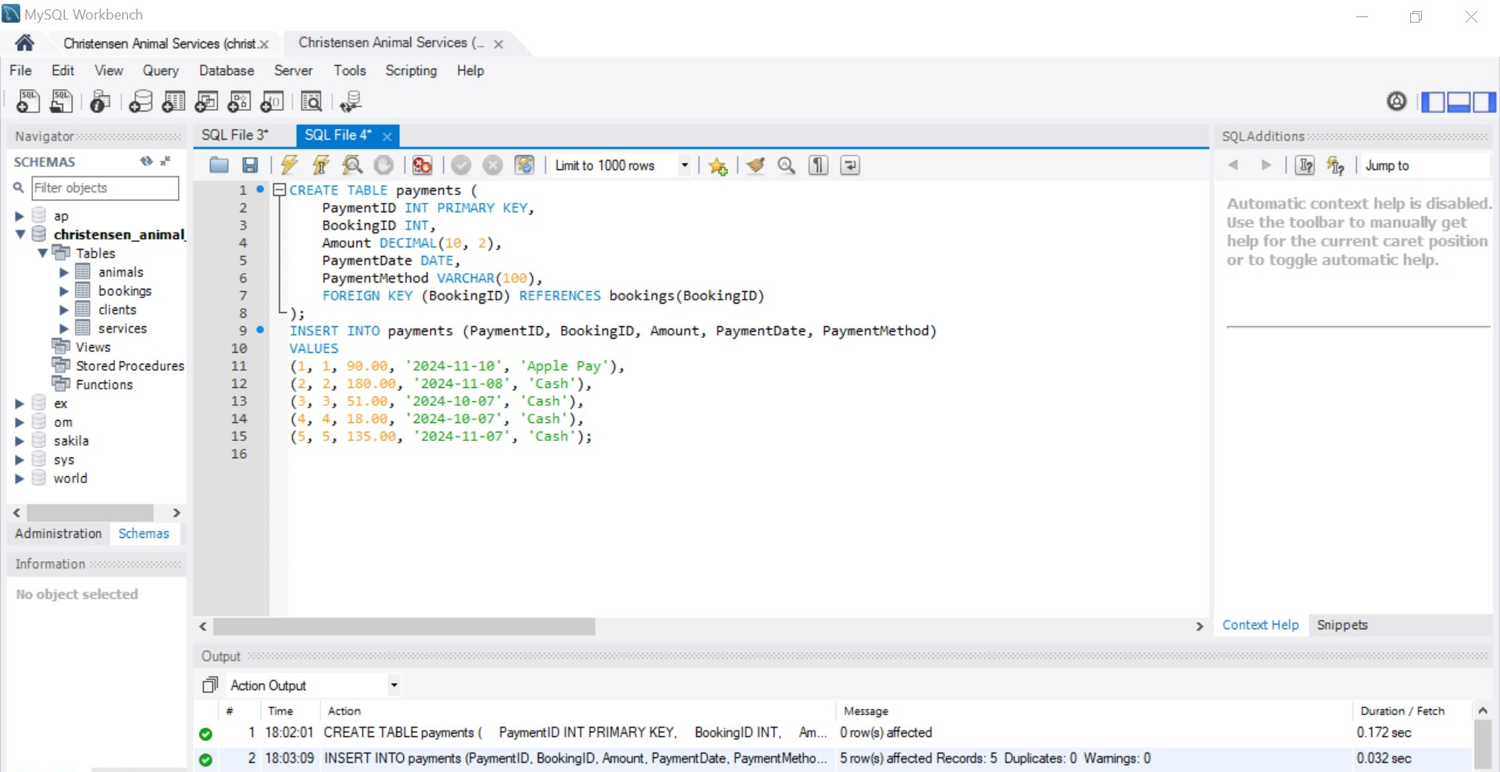
Creating Views:

Client Bookings:
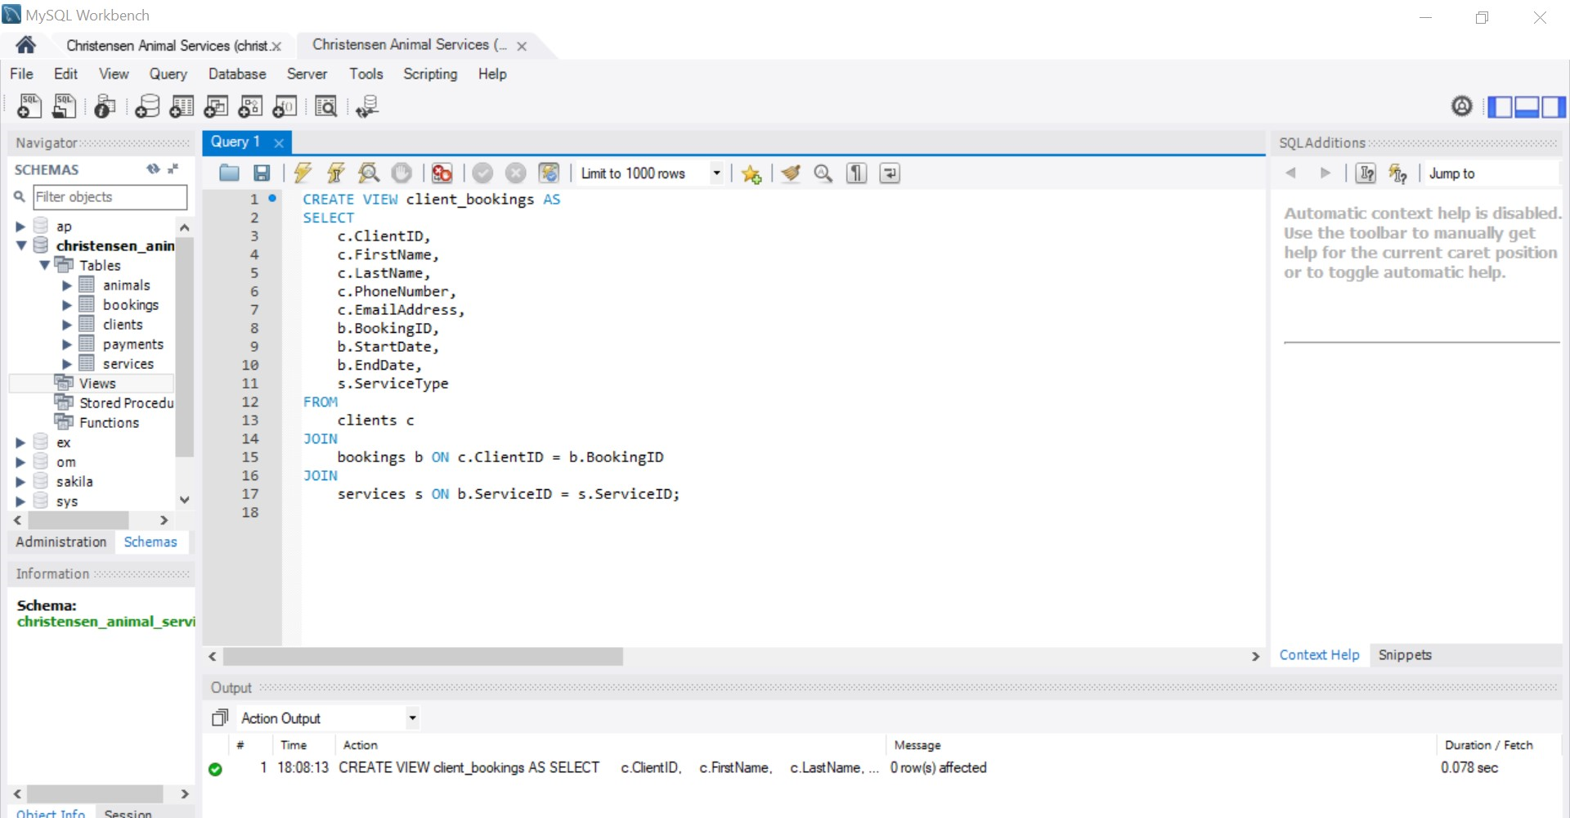
Payment Summary: 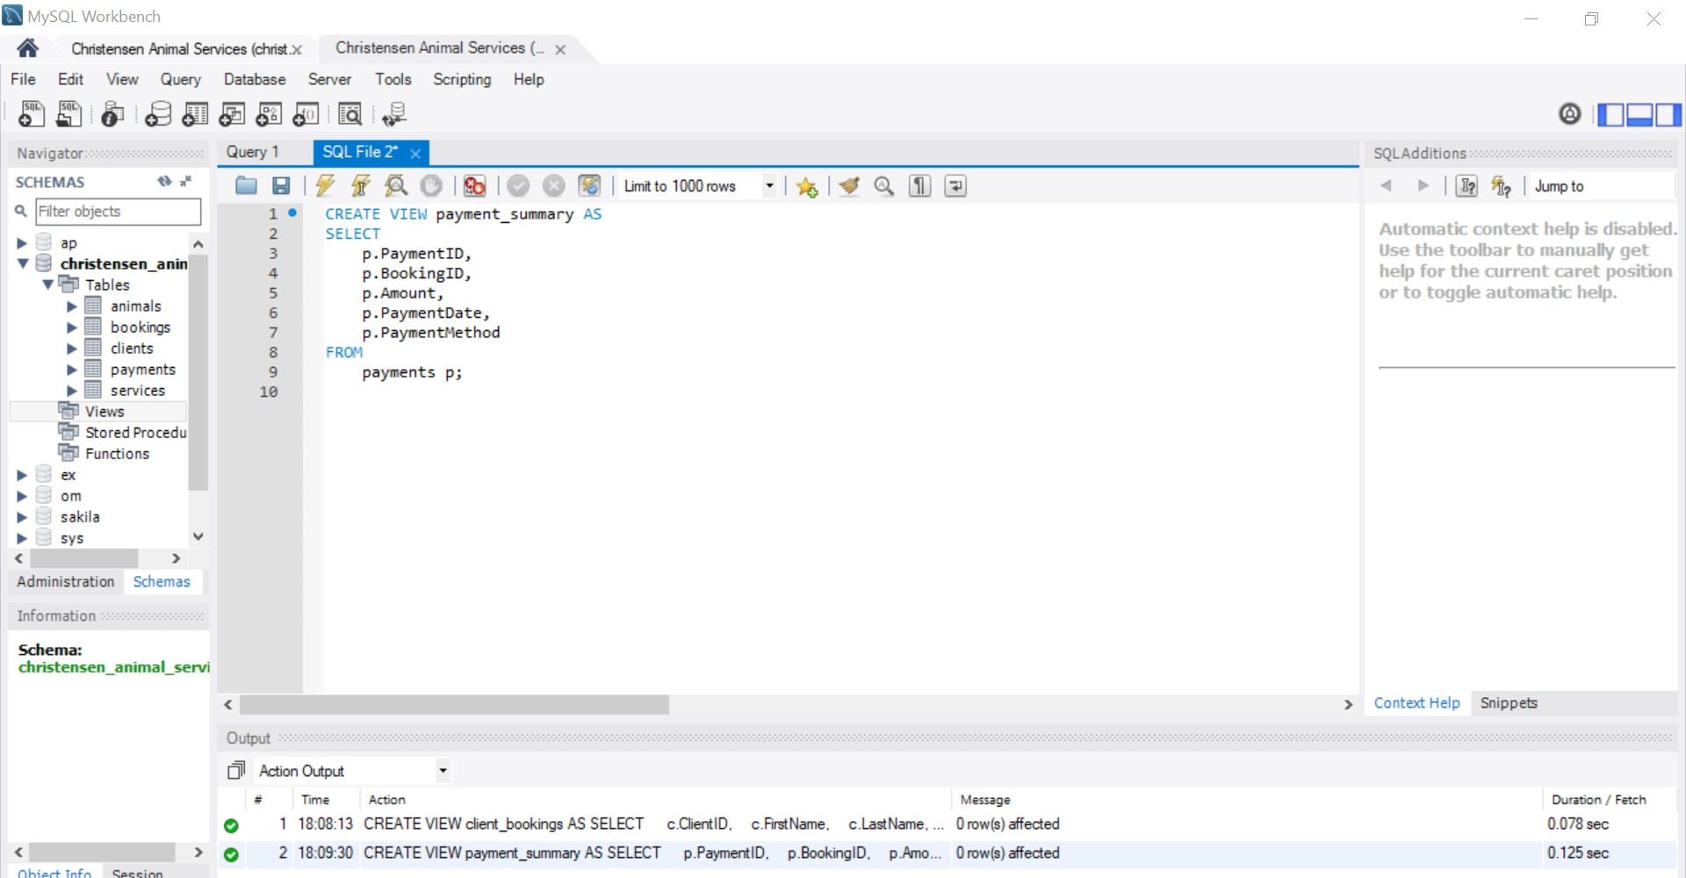
Animal Bookings: 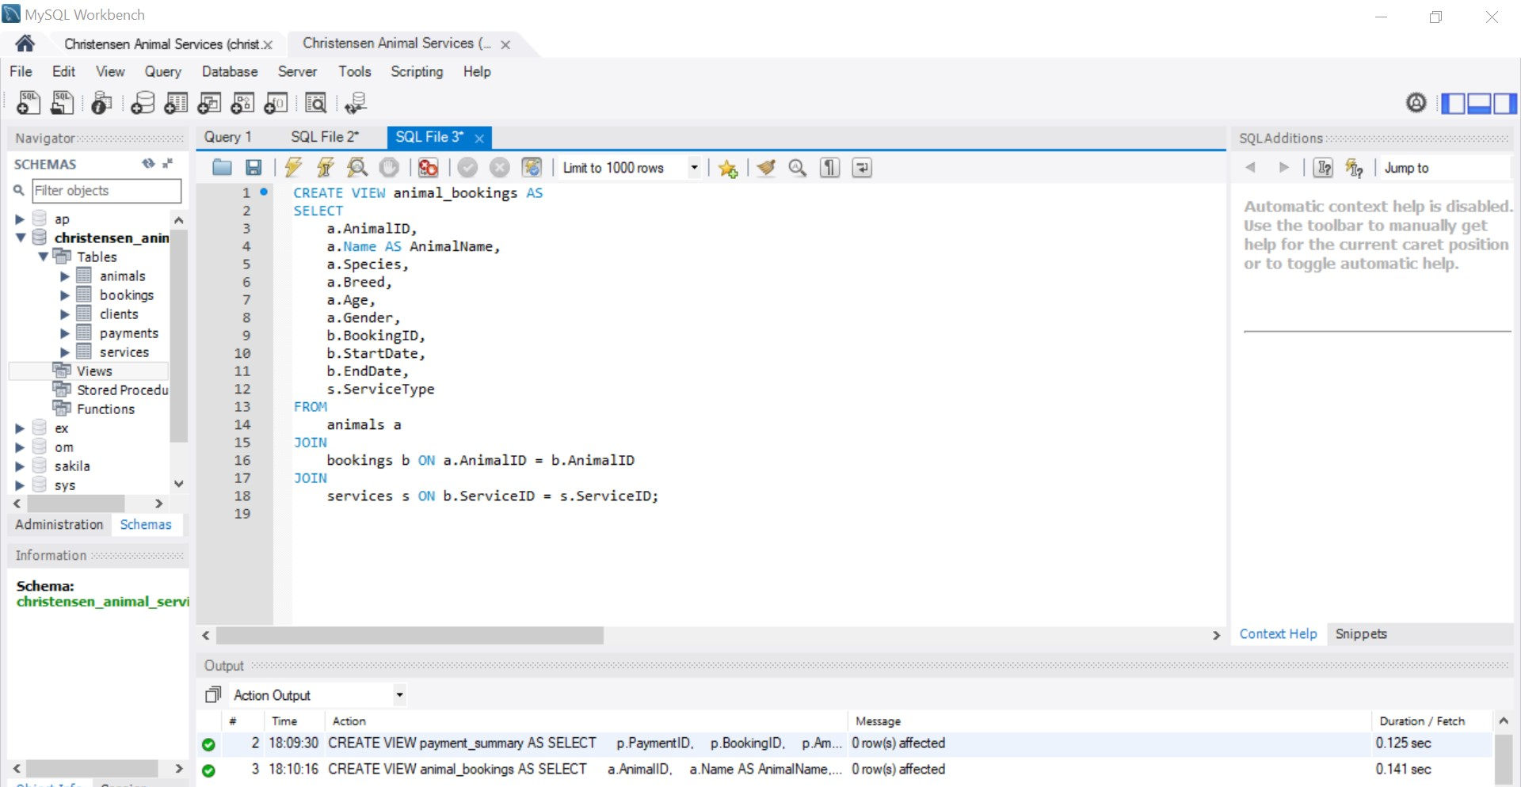
Clients with Pets: 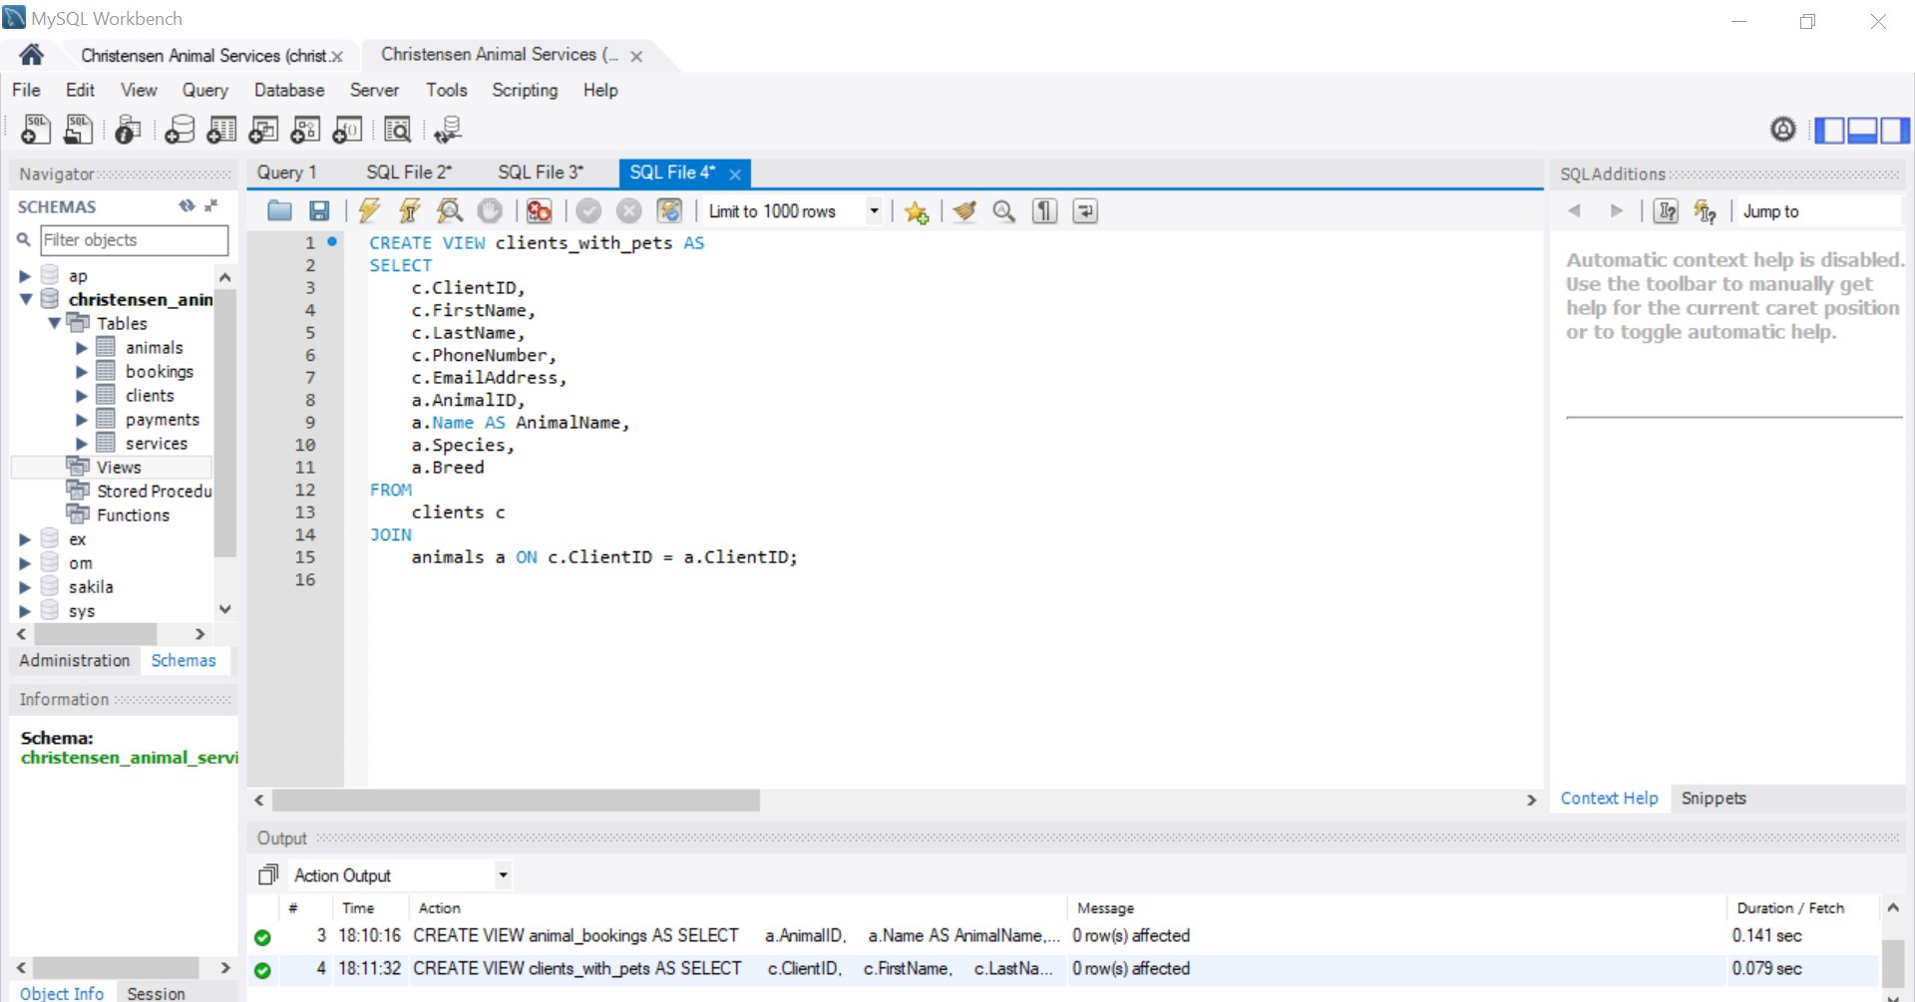
Service Payment Summary: 

