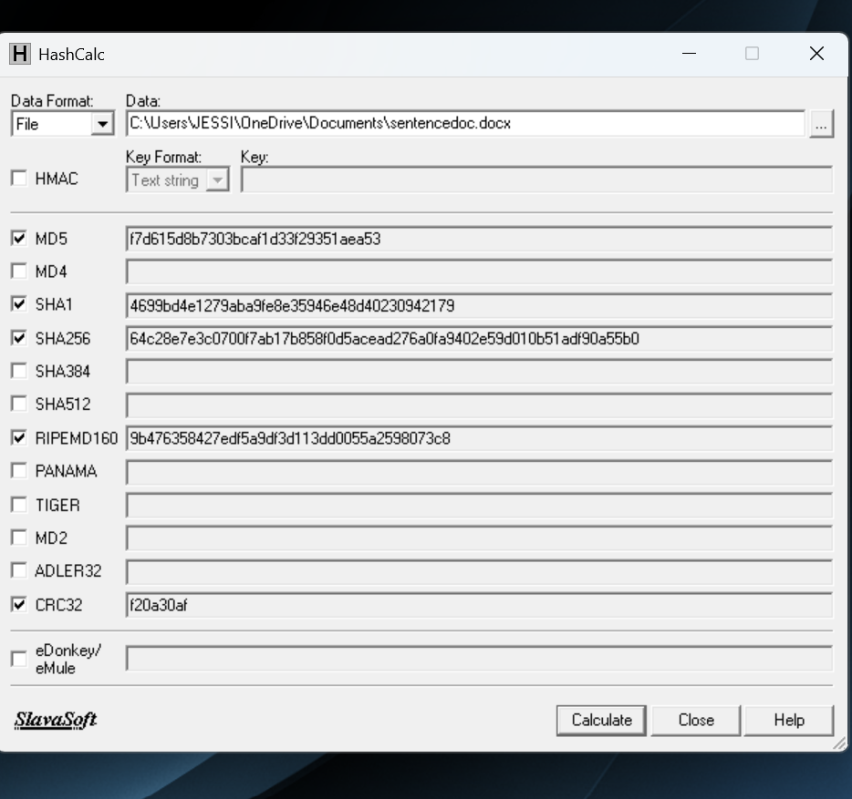
WITHOUT PERIOD

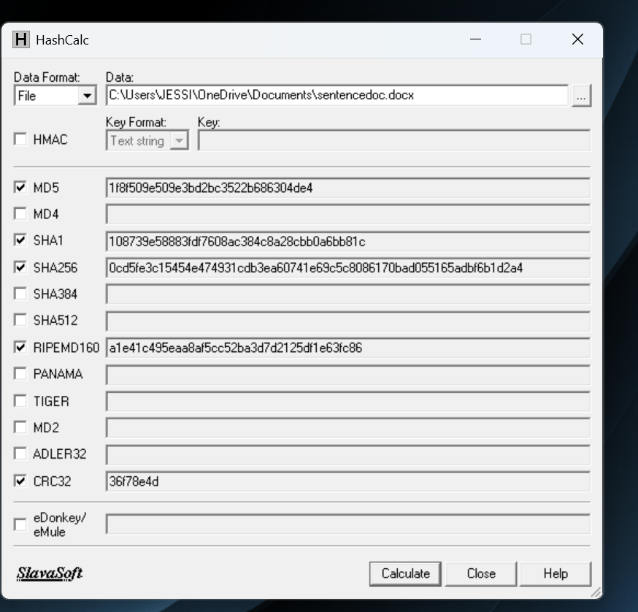

WITH PERIOD
The hash values will be drastically different on purpose. When you hash you are creating values for that specific text and if there are any differences at all between hashes it means they aren’t the exact same. Even a period with or without will still change the files hashes because its not exactly the same.

