Kali Linux Lab
Jessica Christensen
Start Kali Linux Screenshots:
Verify Network Configuration by running ip a screenshot:
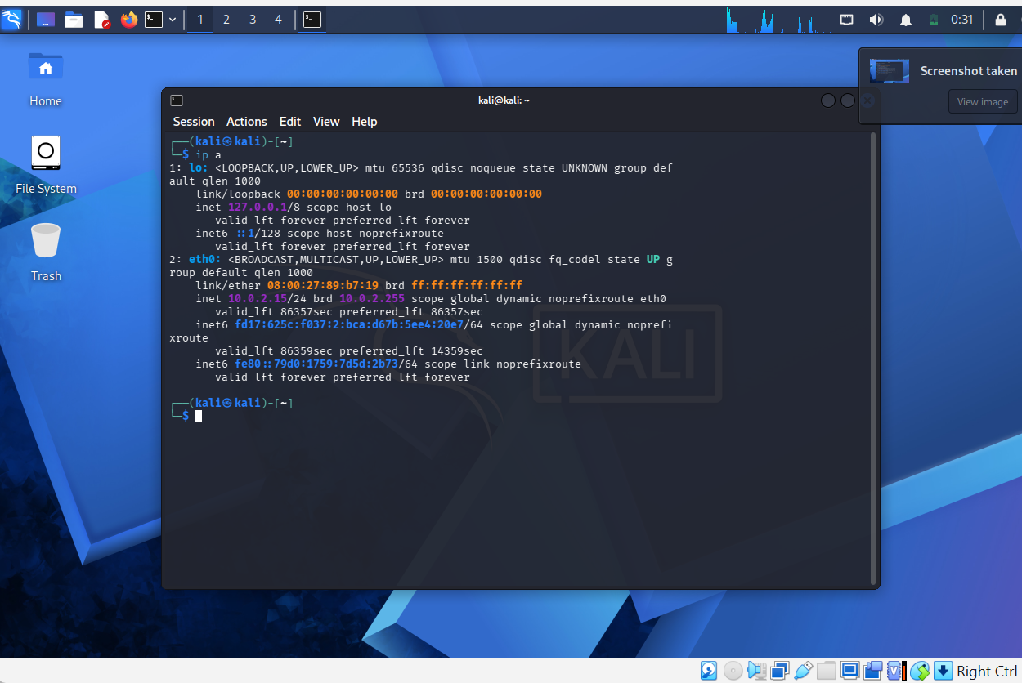
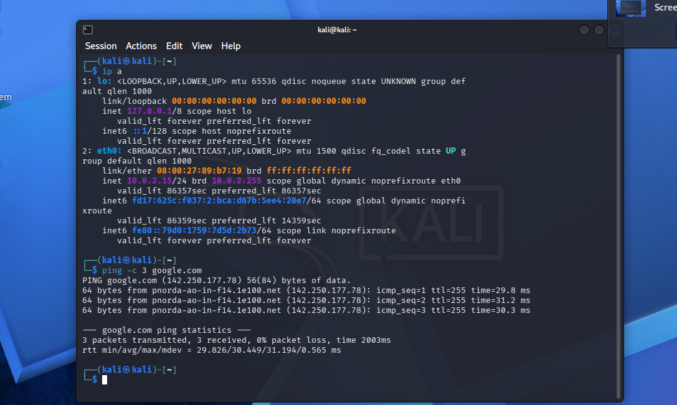
Running ping -c 3 google.com screenshot:

Vulnerability Assessment Using Kali Linux Tools:
Tool #1 Nmap
Running nmap -sV 127.0.0.1 screenshot:
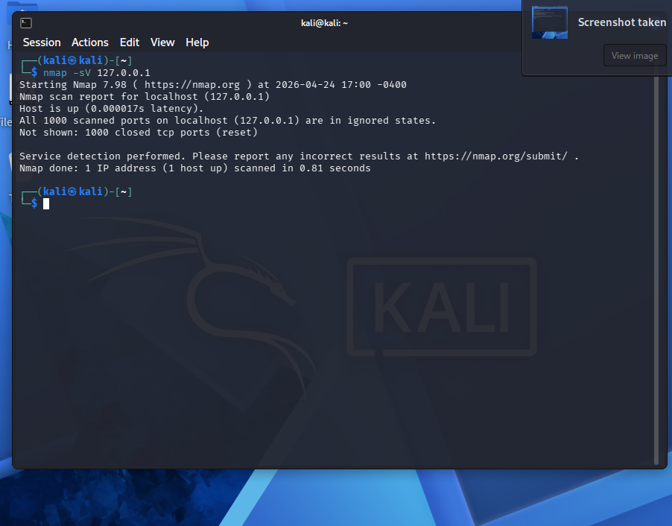
Running nmap with my host machine address screenshot:
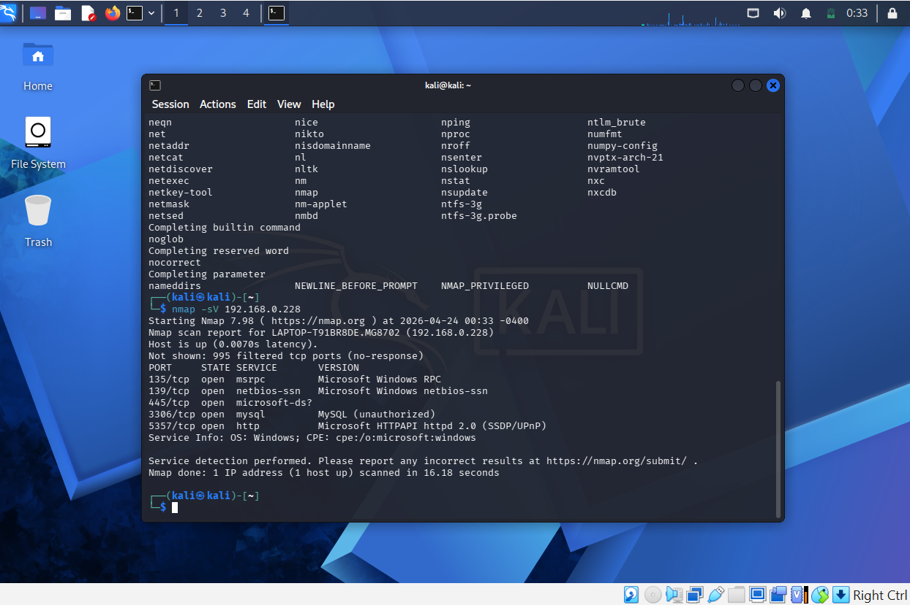
My findings such as services and ports:
When scanning my own network for open services and ports the ports that were open were ports 135(MSRPC), 139(NetBIOS), 445(SMB), 3306(MySQL), and 5357(HTTP/Web Services for Devices). Ports 139 and 445 are important because they are commonly targeted in attacks involving file sharing vulnerabilities such as SMB exploits. Port 3306 shows that I have a database service that is running which could be a security risk if its not properly secured with authentication and firewalls. Port 135 is used for remote calls which could be exploited if vulnerabilities are there. Port 5357 can expose system or device related information that could help an attacker during reconnaissance. In all these findings show that my system has multiple exposed services that should be carefully secured through proper configuration, authentication and regular updates to avoid exploitation.
Tool #2 Nikto
Running nikto -h http://127.0.0.1 screenshot
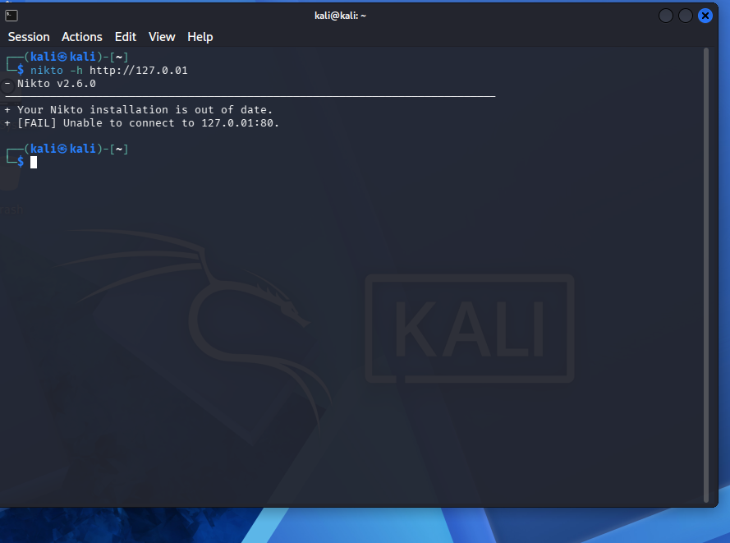
Running nikto -h http://google.com screenshot
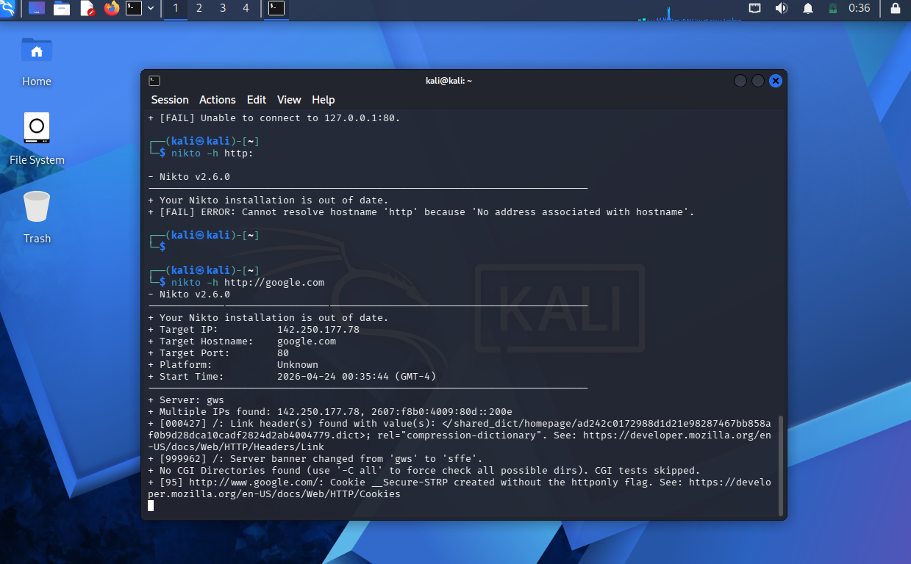
My findings:
The nikto scan showed that it was out of date when I use http://127.0.0.1. Since it stated it was outdated that could mean it would limit the accuracy of the results. When I used http://google.com it did show target IP addresses, associated ports, confirming that the system is reachable. The presence of multiple IP addresses may indicate additional network configurations or related systems. The detection of a link header shows that the server is trying to provide extra information in its HTTP responses. This can provide an attacker with details during reconnaissance. Overall the results show the importance of keeping security tools updated to ensure accurate vulnerability detection and reducing unnecessary information disclosure from web servers.
Tool #3 Searchsploit
Running searchsploit apache screenshots
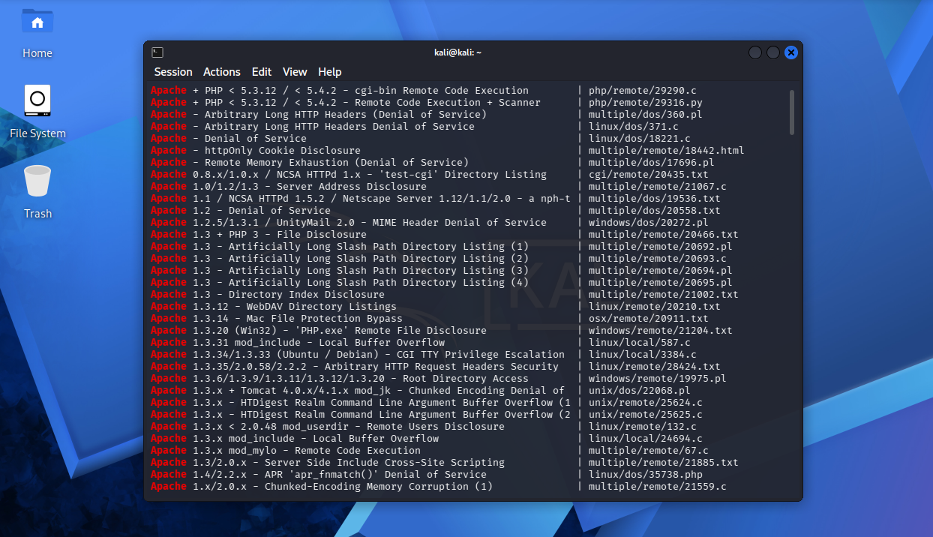
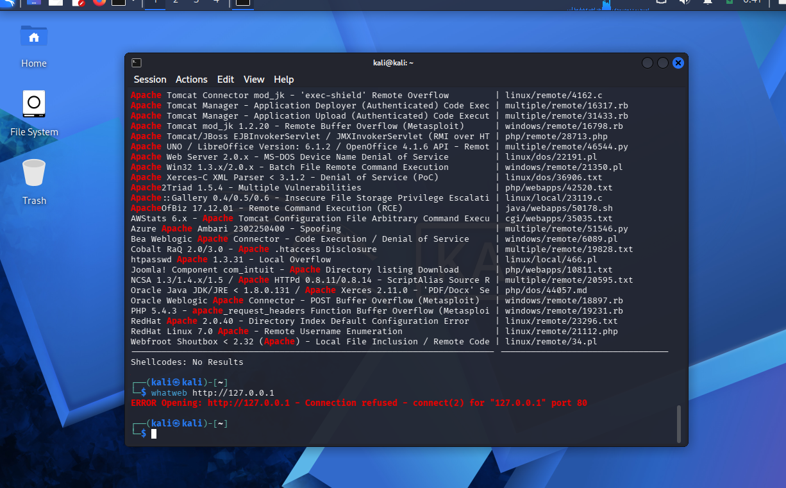
My findings:
The searchsploit results for apache revealed known vulnerabilities including remote code execution, path traversal, and denial of service exploits. These findings show that Apache servers can be vulnerable if not properly updated and secured though actual risk depends on the specific version and configuration.
Tool #4 Whatweb
Running whatweb http://127.0.0.1 screenshot
Running whatweb http://google.com screenshot
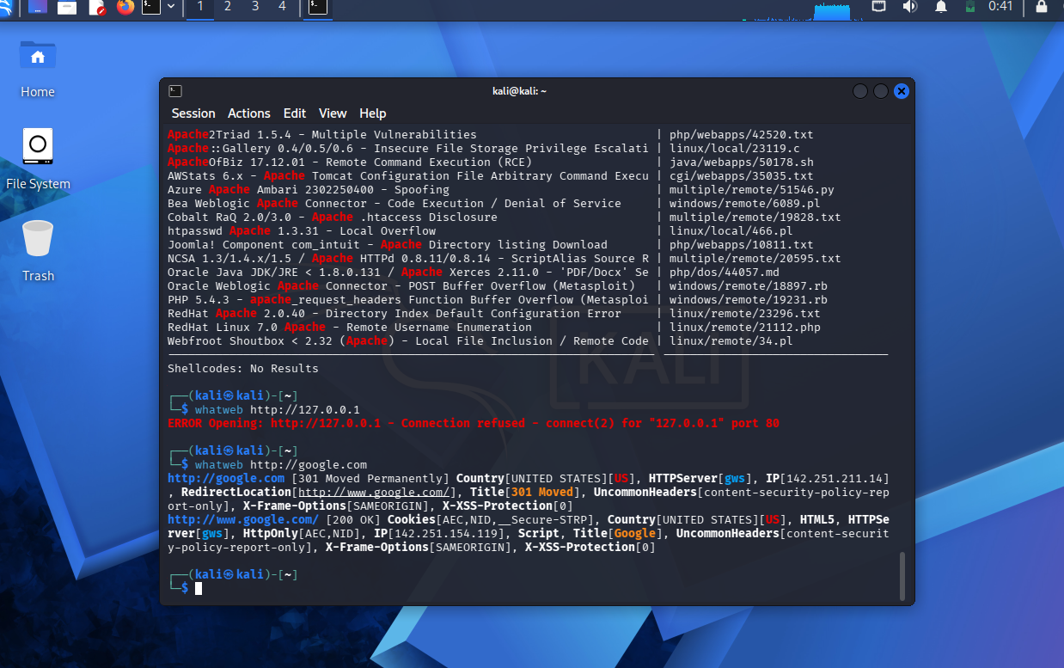
My findings:
The whatweb scan produced different results depending on the target. When scanning the http://127.0.0.1 the connection was refused which indicates that no web server is running locally. This aligns with previous scans that did not detect an open HTTP port. When scanning google.com it returned detailed information about the website, including IP addresses, location, and cookie data. This demonstrates how whatweb can gather useful reconnaissance information when a web server is present. These findings show how whatweb is effective for identifying web technologies and gathering public information.
Additional Tool Exploration
Name of Tool: Fierce
Purpose and description of Tool: The Fierce Tool is a DNS reconnaissance tool used to discover subdomains, IP addresses, and other domain related information. It helps security professionals map out a targets external network by identifying systems that may not be immediately visible. The tool performs DNS look ups and attempts to find subdomains using brute force techniques. This type of information is useful during the reconnaissance phase of a security assessment because it can reveal additional targets and expand the overall attack surface.
List of Findings upon execution of Tool:
I used google.com as the example domain and found plenty of information. It identified multiple IP addresses and subdomains associated with the target domain. Although no zone transfer was successful the results demonstrate how DNS reconnaissance can reveal additional systems and expand the attack surface.
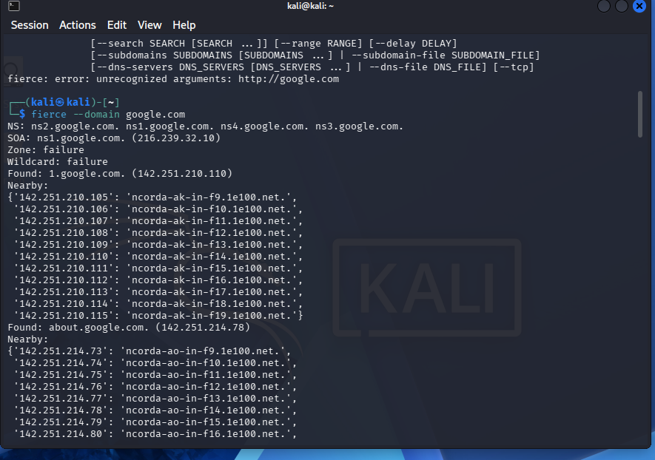
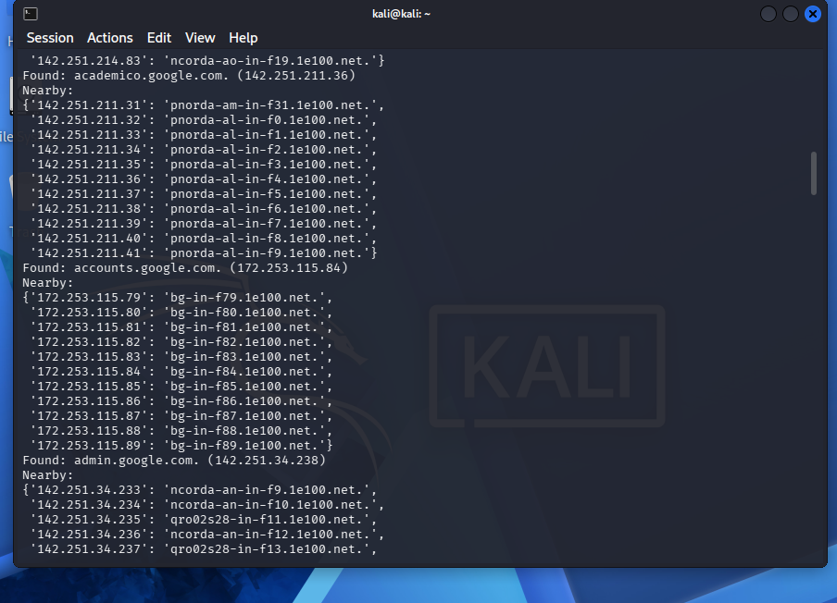
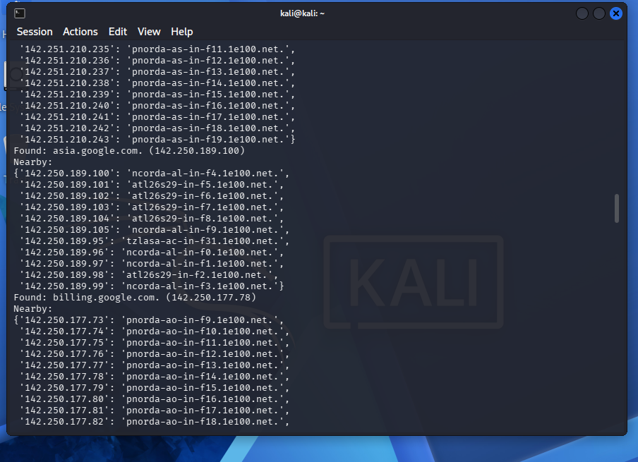
Reflection Questions:
a.Why is virtualization important in security testing?
Virtualization is important because it allows security testing to be performed in a safe controlled environment without affecting real systems. It allows users to simulate networks, test vulnerabilities, and run potentially harmful tools without risk. Virtual machines can also easily be reset making them ideal for repeated testing.
b. Which tool provided the most useful results and why?
I would say Nmap provides the most useful results because it identified open ports and active services on the system. This information is essential for understanding what is exposed and helped guide the use of other tools for deeper analysis.
c. What are the limitations of automated vulnerability scanners?
Automated vulnerability scanners rely on known vulnerability databases so they may not detect new or unknown threats. They can also produce false positives or miss vulnerabilities due to system configuration or lack of context. This is why manual analysis is still necessary.
d. How could false positives impact an organization?
False positives can waste time and resources by causing security teams to investigate issues that are not actual threats. This can delay the response to real vulnerabilities and may reduce overall efficiency. In some cases it can also disrupt normal operations.

