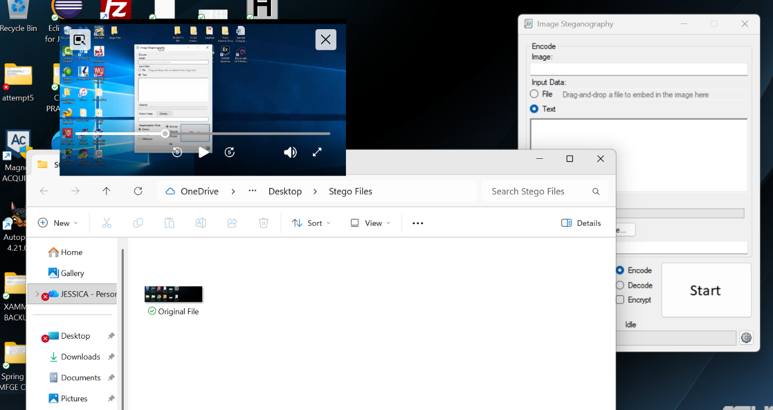
After installing Image Steganography I created the original file screenshot image.
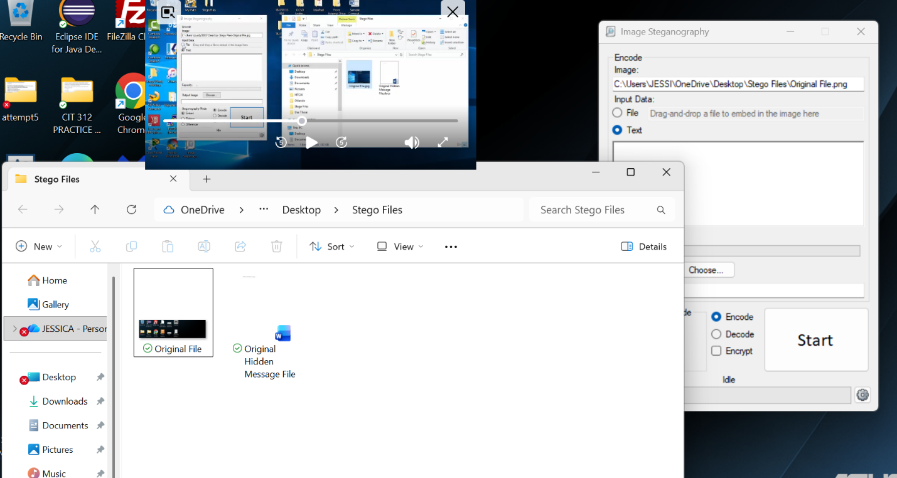
I then created the word document that included the hidden message “This is a hidden message.”
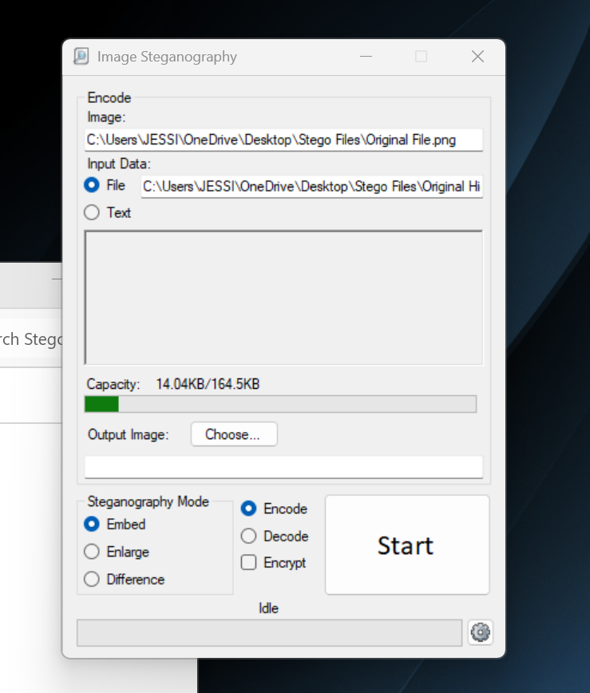
I took the screenshot image and then input the word document file within it. This embedded and encoded the image to have the hidden message within it.
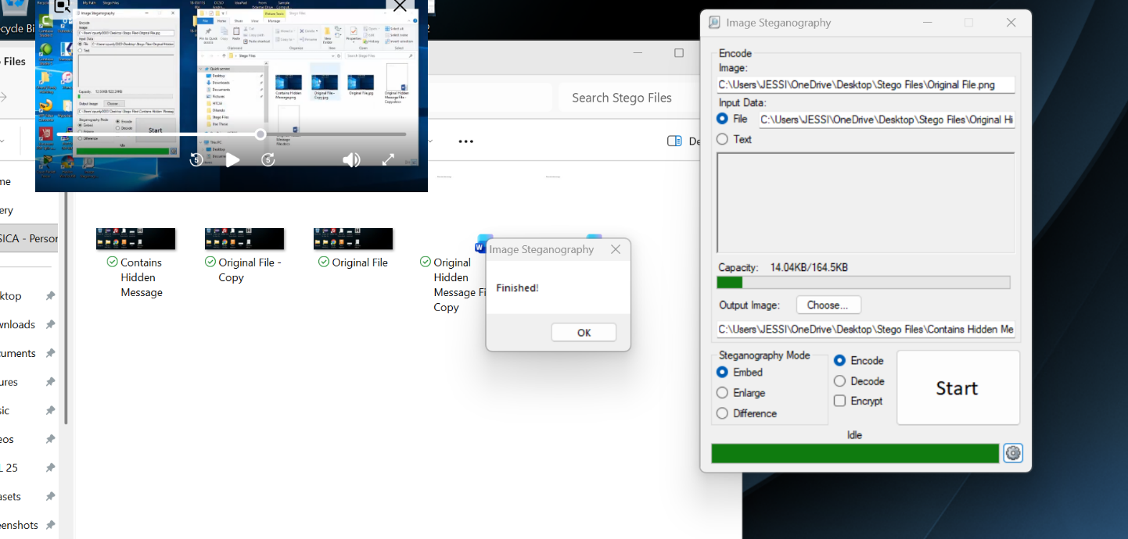
This was me embedding the screenshot with the hidden message.
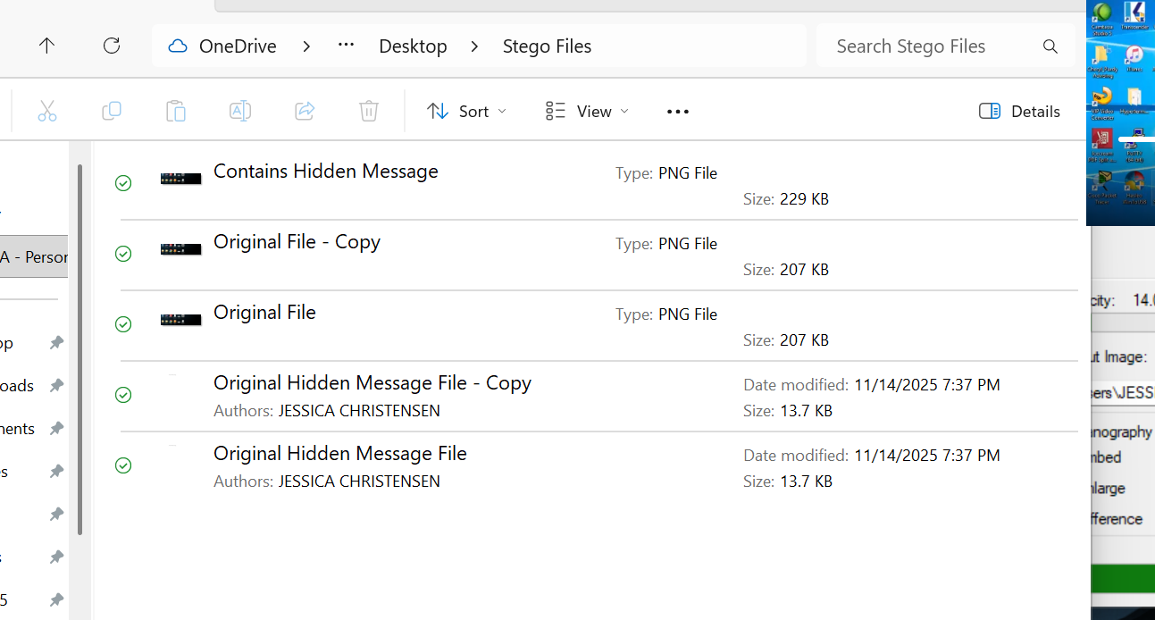
This screenshot shows how the file sizes can help you determine which ones have an image embedded within in. After I embedded it with the hidden message the image grew from 207KB to 229KB,
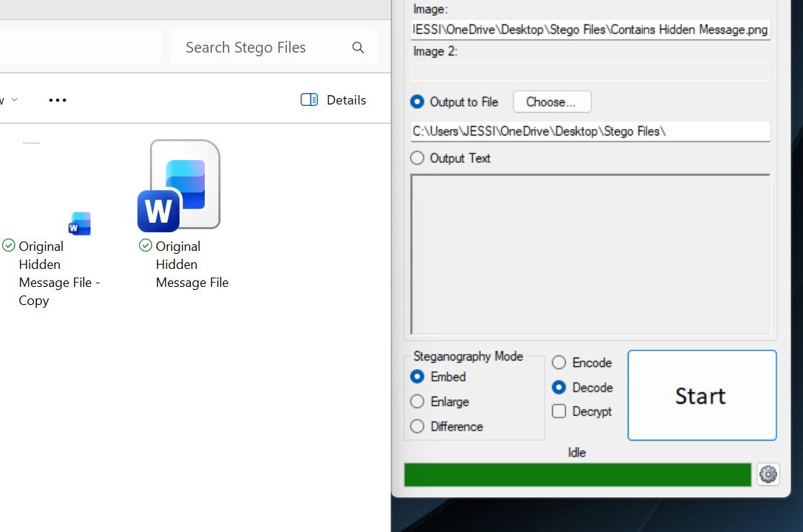
To decode the image, you must select the image with the hidden message in it and then delete the original file image so it will create the message decrypted. In this screenshot I decode the message from the image


